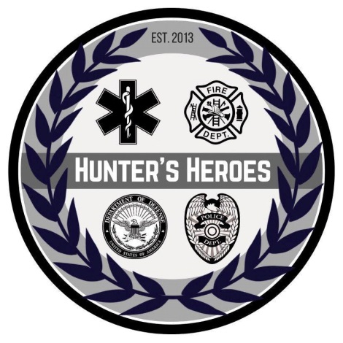

Dear Community Partner,

On June 8, 2012, Peyton Townsend, age 4, passed away from a tragic accident. Peyton’s parents, Sarah, a nurse, and Randall, a paramedic and state trooper, established the Lilly Grace College Fund in Peyton’s memory. On July 26, 2012, the Watauga County Sheriff’s Department and the community of Watauga County was devastated by the loss of Deputy William Mast, Jr. That day marked the rise of a hero who will never be forgotten. From these tragic events we created Hunter’s Heroes, a 100% volunteer non-profit to honor the deceased and, more importantly, keep their memories alive in our community. Hunter’s Heroes, established on August 16, 2013 was named for Hunter Mast, the son of Deputy William Mast, Jr. & his wife Paige Mast. Every year it benefits a family who gave the ultimate sacrifice. Paige and Hunter were the first recipients in 2013. For more information on the rest of our past recipients please visit our website. The 7th annual Hunter’s Heroes Memorial Run and Celebration will be held on May 18th at 8:30 a.m. This year, the run will be in memory of James Randall, “Randy” Collins, who passed away Thursday afternoon, August 30, 2018. While in Boone, he served as Chief of Watauga County Rescue for 26 years. Winston Churchill once said, “We make a living by what we get, but we make a life by what we give.” This is just one of the many thoughts that describe a man that had a servant’s heart. The proceeds from our memorial run and celebration will be given to the Randy Collins Athletic Training Scholarship-Yosef Club.

Hunter’s Heroes main objective, is to pay tribute to those we have lost and offer comfort to their families. We want to inspire our community to remember those who gave the ultimate sacrifice and to embrace the loved ones who lost a family member. Please consider joining our efforts by becoming one of Hunter’s Heroes. We will continue to honor Deputy William Mast, Jr., Peyton Elizabeth Townsend, Major Ryan Scott David, Katie Watson, Officer Jason M. Crisp, Jenny McCourry, Travis Gryder, Leda Winebarger, State Trooper Benjamin Chappell, & Elayne Bishop, Sergeant Dillon C. Baldridge, and Levi Boyter. We are continuing to support scholarships and assist families in the community that are suffering hardships.

Hunter’s Heroes relies entirely on individual donations and on fundraisers to inform the community of our mission, to support our Travis Jake Gryder scholarship fund, and to assist families in our community that are in need of financial support. Hunter’s Heroes is a NC state non-profit: Tax ID Number is 46-6353664 and is currently written legally under William Hunter Mast Scholarship Fund.

Sincerely,

Team Hunter’s Heroes

